**EXERCISE-2**

**How to Create Named Ranges in Excel (A Step-by-step Guide)**

**Named Ranges in Excel – An Introduction**

In this data set, if you have to refer to the range that has the Date, you will have to use A2:A11 in formulas. Similarly, for Sales Rep and Sales, you will have to use B2:B11 and C2:C11.

While it’s alright when you only have a couple of data points, but in case you huge complex data sets, using cell references to refer to data could be time-consuming.

Excel Named Ranges makes it easy to refer to data sets in Excel.

You can create a named range in Excel for each data category, and then use that name instead of the cell references. For example, dates can be named ‘Date’, Sales Rep data can be named ‘SalesRep’ and sales data can be named ‘Sales’.

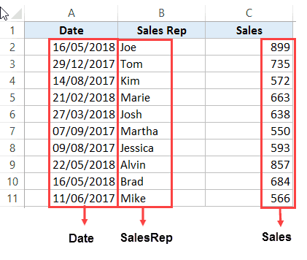

## 

If someone has to call me or refer to me, they will use my name (instead of saying a male is staying in so and so place with so and so height and weight).

Right?

Similarly, in Excel, you can give a name to a cell or a range of cells.

Now, instead of using the cell reference (such as A1 or A1:A10), you can simply use the name that you assigned to it.

For example, suppose you have a data set as shown below:

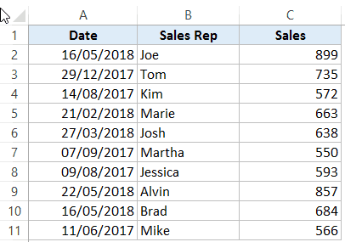

## You can also create a name for a single cell. For example, if you have the sales commission percentage in a cell, you can name that cell as ‘Commission’.

## Benefits of Creating Named Ranges in Excel

Here are the benefits of using named ranges in Excel.

### Use Names instead of Cell References

When you create Named Ranges in Excel, you can use these names instead of the cell references.

For example, you can use =SUM(SALES) instead of =SUM(C2:C11) for the above data set.

Have a look at ṭhe formulas listed below. Instead of using cell references, I have used the Named Ranges.

* Number of sales with value more than 500: =[COUNTIF](https://trumpexcel.com/excel-countif-function/)(Sales,”>500″)
* Sum of all the sales done by Tom: =SUMIF(SalesRep,”Tom”,Sales)
* Commission earned by Joe (sales by Joe multiplied by commission percentage):  
  =[SUMIF](https://trumpexcel.com/excel-sumif-function/)(SalesRep,”Joe”,Sales)*Commission

### No Need to Go Back to the Dataset to Select Cells

Another significant benefit of using Named Ranges in Excel is that you don’t need to go back and select the cell ranges.

You can just type a couple of alphabets of that named range and Excel will show the matching named ranges (as shown below):

=SUM(SALES) you may get 6757 in the above data table.

### Named Ranges Make Formulas Dynamic

By using Named Ranges in Excel, you can make Excel formulas dynamic.

For example, in the case of sales commission, instead of using the value 2.5%, you can use the Named Range.

Now, if your company later decides to increase the commission to 3%, you can simply update the Named Range, and all the calculation would automatically update to reflect the new commission.

## How to Create Named Ranges in Excel

Here are three ways to create Named Ranges in Excel:

### Method #1 –  Using Define Name

Here are the steps to create Named Ranges in Excel using Define Name:

* Select the range for which you want to create a Named Range in Excel. 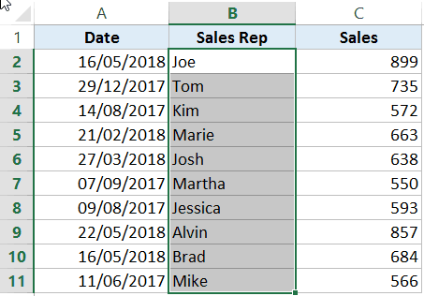
* Go to Formulas –> Define Name.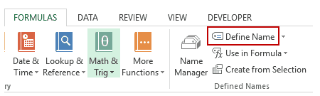

In the New Name dialogue box, type the Name you wish to assign to the selected data range. You can specify the scope as the entire workbook or a specific worksheet, If you select a particular sheet, the name would not be available on other sheets.

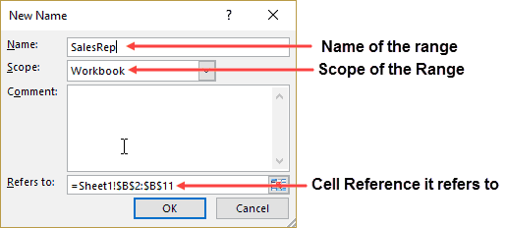

* Click OK.

This will create a Named Range SALESREP.

### Method #2: Using the Name Box

* Select the range for which you want to create a name (do not select headers).
* Go to the Name Box on the left of Formula bar and Type the name of the with which you want to create the Named Range.How to Create Named Ranges in Excel - Name Box
* Note that the Name created here will be available for the entire Workbook. If you wish to restrict it to a worksheet, use Method 1.

### Method #3: Using Create From Selection Option

This is the recommended way when you have data in tabular form, and you want to create named range for each column/row.

For example, in the dataset below, if you want to quickly create three named ranges (Date, Sales_Rep, and Sales), then you can use the method shown below.



Here are the steps to quickly create named ranges from a dataset:

* Select the entire data set (including the headers).
* Go to Formulas –> Create from Selection (*Keyboard shortcut – Control + Shift + F3*). It will open the ‘Create Names from Selection’ dialogue box.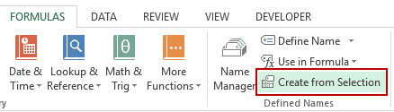

In the Create Names from Selection dialogue box, check the options where you have the headers. In this case, we select top row only as the header is in the top row. If you have headers in both top row and left column, you can choose both. Similarly, if your data is arranged when the headers are in the left column only, then you only check the Left Column option.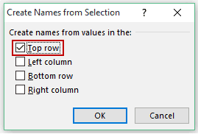 This will create three Named Ranges – Date, Sales_Rep, and Sales.

Note that it automatically picks up names from the headers. If there are any space between words, it inserts an underscore (as you can’t have spaces in named ranges).

### Naming Convention for Named Ranges in Excel

There are certain naming rules you need to know while creating Named Ranges in Excel:

* The first character of a Named Range should be a letter and underscore character(_), or a backslash(\). If it’s anything else, it will show an error. The remaining characters can be letters, numbers, special characters, period, or underscore.
* You can not use names that also represent cell references in Excel. For example, you can’t use AB1 as it is also a cell reference.
* You can’t use spaces while creating named ranges. For example, you can’t have Sales Rep as a named range. If you want to combine two words and create a Named Range, use an underscore, period or uppercase characters to create it. For example, you can have Sales_Rep, SalesRep, or SalesRep.
  + While creating named ranges, Excel treats uppercase and lowercase the same way. For example, if you create a named range SALES, then you will not be able to create another named range such as ‘sales’ or ‘Sales’.
* A Named Range can be up to 255 characters long.

## Too Many Named Ranges in Excel? Don’t Worry

Sometimes in large data sets and complex models, you may end up creating a lot of Named Ranges in Excel.

What if you don’t remember the name of the Named Range you created?

Don’t worry – here are some useful tips.

### **Getting the Names of All the Named Ranges**

Here are the steps to get a list of all the named ranges you created:

* Go to the Formulas tab.
* In the Defined Named group, click on Use in Formula.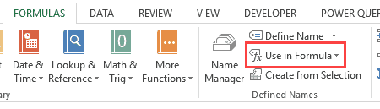
* Click on ‘Paste Names’. 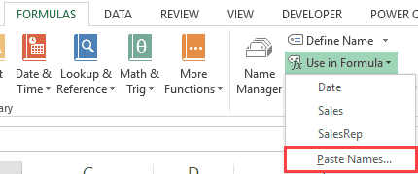

This will give you a list of all the Named Ranges in that workbook. To use a named range (in formulas or a cell), double click on it.

This will give you a list of all the Named Ranges in that workbook. To use a named range (in formulas or a cell), double click on it.

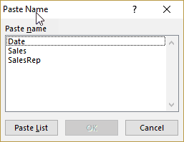

### **Displaying the Matching Named Ranges**

* If you have some idea about the Name, type a few initial characters, and Excel will show a drop down of the matching names.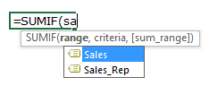

## How to Edit Named Ranges in Excel

If you have already created a Named Range, you can edit it using the following steps:

* Go to the Formulas tab and click on Name Manager.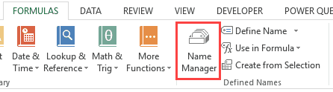
* The Name Manager dialog box will list all the Named Ranges in that workbook. Double click on the Named Range that you want to edit. 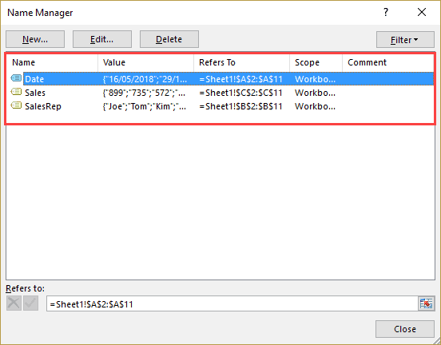
* In the Edit Name dialog box, make the changes.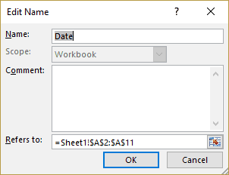
* Click OK.
* Close the Name Manager dialog box.

## Useful Named Range Shortcuts (the Power of F3)

Here are some useful [keyboard shortcuts](https://trumpexcel.com/excel-keyboard-shortcuts/) that will come handy when you are working with Named Ranges in Excel:

* To get a list of all the Named Ranges and pasting it in Formula: **F3**
* To create new name using Name Manager Dialogue Box: **Control + F3**
* To create Named Ranges from Selection: **Control + Shift + F3**

## Creating Dynamic Named Ranges in Excel

So far in this tutorial, we have created static Named Ranges.

This means that these Named Ranges would always refer to the same dataset.

For example, if A1:A10 has been named as ‘Sales’, it would always refer to A1:A10.

If you add more sales data, then you would have to manually go and update the reference in the named range.

In the world of ever-expanding data sets, this may end up taking up a lot of your time. Every time you get new data, you may have to update the Named Ranges in Excel.

To tackle this issue, we can create Dynamic Named Ranges in Excel that would automatically account for additional data and include it in the existing Named Range.

For example, For example, if I add two additional sales data points, a dynamic named range would automatically refer to A1:A12.

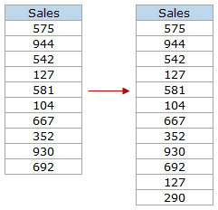

This kind of Dynamic Named Range can be created by using [Excel INDEX function](https://trumpexcel.com/excel-index-function/). Instead of specifying the cell references while creating the Named Range, we specify the formula. The formula automatically updated when the data is added or deleted.

Let’s see how to create Dynamic Named Ranges in Excel.

Suppose we have the sales data in cell A2:A11.

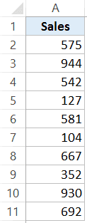

Here are the steps to create Dynamic Named Ranges in Excel:

* 1. Go to the Formula tab and click on Define Name. 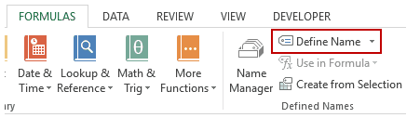
  2. In the New Name dialogue box type the following:
     + Name: Sales
     + Scope: Workbook
     + Refers to: =$A$2:INDEX($A$2:$A$100,COUNTIF($A$2:$A$100,”<>”&””)) 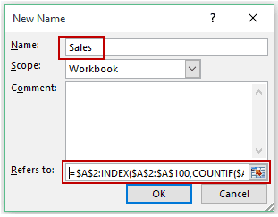
  3. Click OK.

Done!

You now have a dynamic named range with the name ‘Sales’. This would automatically update whenever you add data to it or remove data from it.

### How does Dynamic Named Ranges Work?

To explain how this work, you need to know a bit more about Excel INDEX function.

Most people use INDEX to return a value from a list based on the row and column number.

But the INDEX function also has another side to it.

It can be used to **return a cell reference** when it is used as a part of a cell reference.

For example, here is the formula that we have used to create a dynamic named range:

=$A$2:INDEX($A$2:$A$100,COUNTIF($A$2:$A$100,"<>"&""))

INDEX($A$2:$A$100,COUNTIF($A$2:$A$100,”<>”&””) –> This part of the formula is expected to return a value (which would be the 10th value from the list, considering there are ten items).

However, when used in front of a reference (=**$A$2:**INDEX($A$2:$A$100,COUNTIF($A$2:$A$100,”<>”&””))) it returns the reference to the cell instead of the value.

Hence, here it returns =$A$2:$A$11

If we add two additional values to the sales column, it would then return =$A$2:$A$13

When you add new data to the list, [Excel COUNTIF](https://trumpexcel.com/excel-countif-function/) function returns the number of non-blank cells in the data. This number is used by the INDEX function to fetch the cell reference of the last item in the list.

**Note:**

* This would only work if there are no blank cells in the data.
* In the example taken above, I have assigned a large number of cells (A2:A100) for the Named Range formula. You can adjust this based on your data set.

You can also use [OFFSET function](https://trumpexcel.com/excel-offset-function/) to create a Dynamic Named Ranges in Excel, however, since OFFSET function is [volatile](https://trumpexcel.com/excel-volatile-formulas/), it may lead a [slow Excel workbook](https://trumpexcel.com/suffering-from-slow-excel-spreadsheets/). INDEX, on the other hand, is semi-volatile, which makes it a better choice to create Dynamic Named Ranges in Excel.

# Excel Tables

Excel Tables have a confusingly generic name, but they are packed with useful features. If you need a range that expands to include new data, and if you want formulas that automatically stay up to date, Excel Tables are for you. This article provides an overview.

### 1. Creating a table is fast

You can create an Excel Table in less than 10 seconds. First, remove blank rows and make sure all columns have a unique name, then put the cursor anywhere in the data and use the keyboard shortcut Control + T. When you click OK, Excel will create the table.

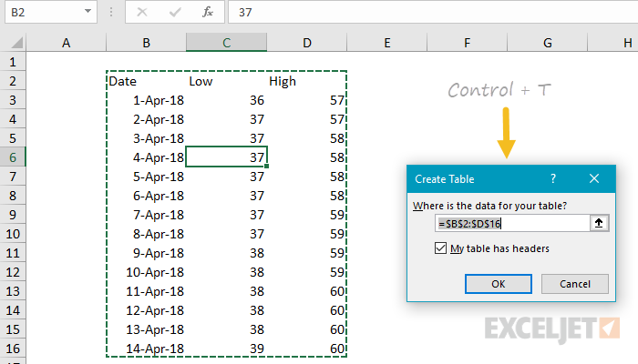

### 2. Navigate directly to tables

Like [named ranges](https://exceljet.net/glossary/named-range), tables will appear in the namebox dropdown menu. Just click the menu, and select the table. Excel will navigate to the table, even if it's on a different tab in a workbook.

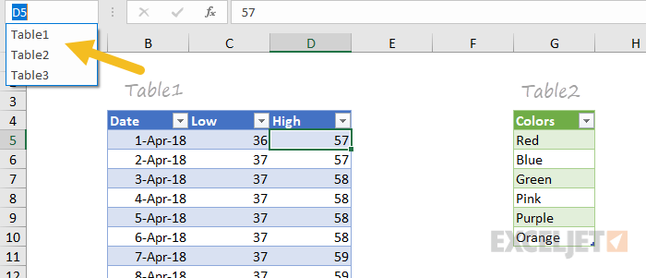

### 3. Tables provide special shortcuts

When you convert regular data to an Excel Table, almost every shortcut you know works better. For example, you can select rows with shift + space, and columns with control + space. These shortcuts make selections that run precisely to the edge of the table, even when you can't see the edge of the table. Watch the video below for a quick rundown.

Video: [Shortcuts for Excel tables](https://exceljet.net/lessons/shortcuts-for-tables)

### 4. Painless drag and drop

Tables make it much easier to rearrange data with drag and drop. After you've selected a table row or column, simply drag to a new location. Excel will quietly insert the selection at the new location, without complaining about overwriting data.

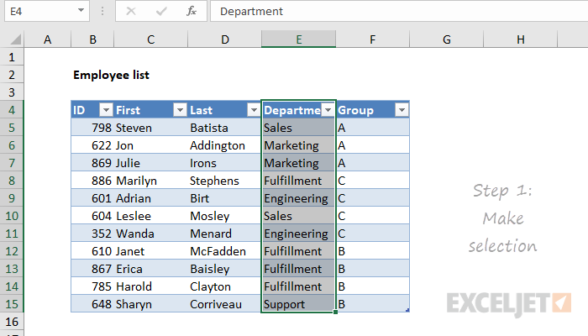

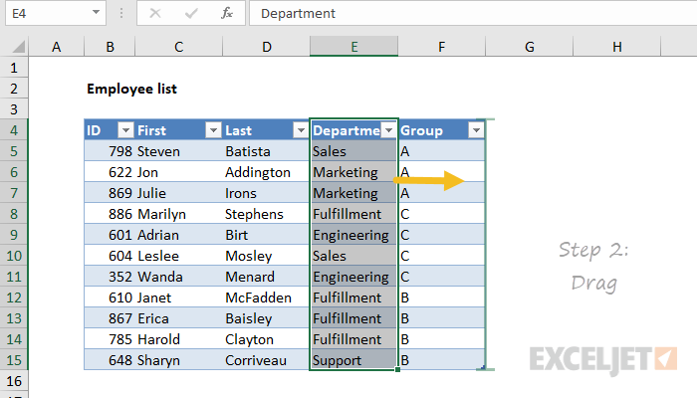

Note: you must [select the entire row or column](https://exceljet.net/lessons/shortcuts-for-tables). For columns, that includes the header.

### 5. Table headers stay visible

One frustration when working with a large set of data is that table headers disappear as you scroll down the table. Tables solve this problem in a clever way. When column headers scroll off the top of the table, Excel silently replaces worksheet columns with table headers.

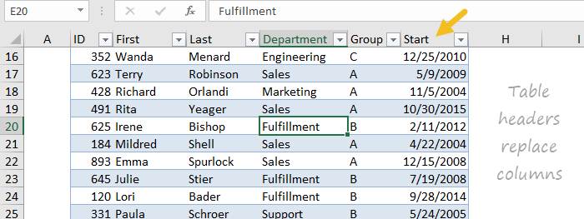

### 6. Tables expand automatically

When new rows or columns are added to an Excel Table, the table expands to enclose them. In a similar way, a table automatically contracts when rows or columns are deleted. When combined with structured references (see below) this gives you a dynamic range to use with formulas.

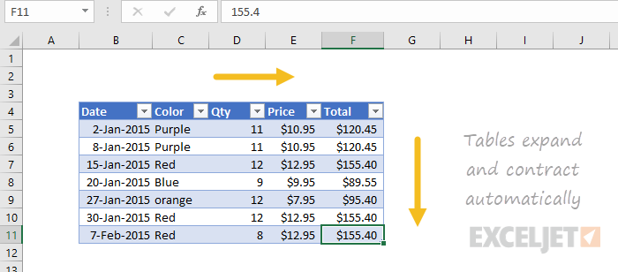

### 7. Totals without formulas

All tables can display an optional Total Row. The Total Row can be easily configured to perform operations like SUM and COUNT without entering a formula. When the table is filtered, these totals will automatically calculate on visible rows only. You can toggle the Total Row on and off with the shortcut control + shift + T.

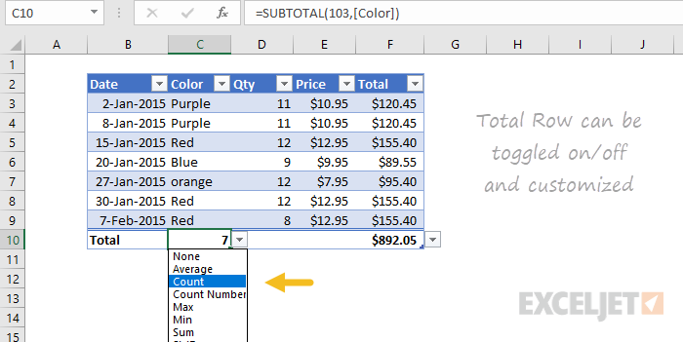

### 8. Rename a table anytime

All tables are automatically assigned a generic name like Table1, Table2, etc. However, you can rename a table at any time. Select any cell in the table and enter a new name on the Table Tools menu.

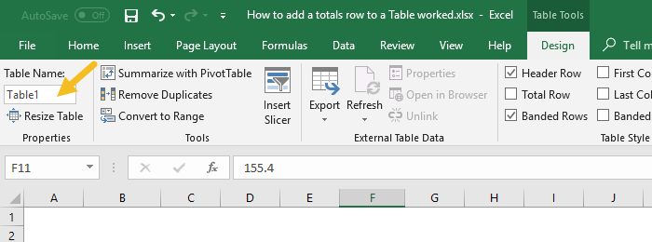

### 9. Fill formulas automatically

Tables have a feature called calculated columns that makes entering and maintaining formulas easier and more accurate. When you enter a standard formula in a column, the formula is automatically copied throughout the column, with no need for copy and paste.

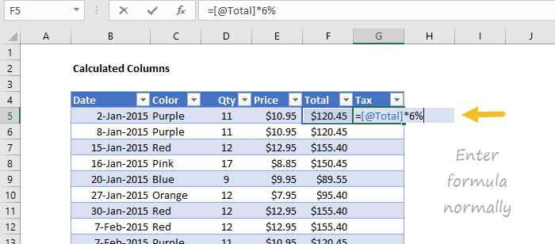

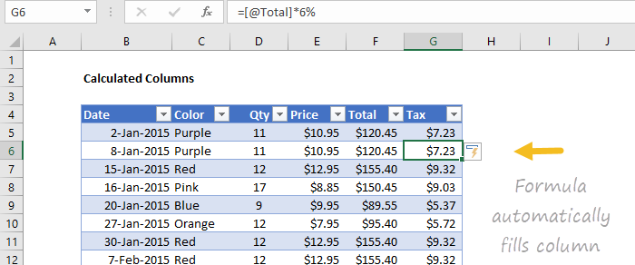

### 10. Change formulas automatically

The same feature also handles formula changes. If you make a change to the formula anywhere in a calculated column, the formula is updated throughout the entire column. In the screen below, the tax rate has been changed to 7% in one step.

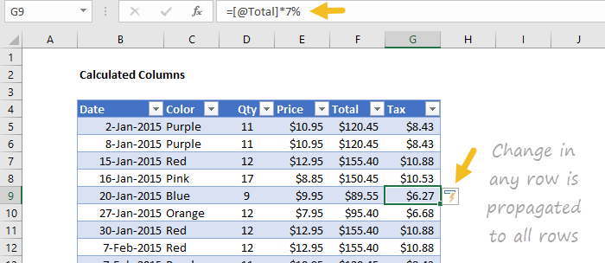

### 11. Human-readable formulas

Tables use a special formula syntax to refer to parts of a table by name. This feature is called "structured references". For example, to SUM a column called "Amount" in a table called "Orders", you can use a formula like this:

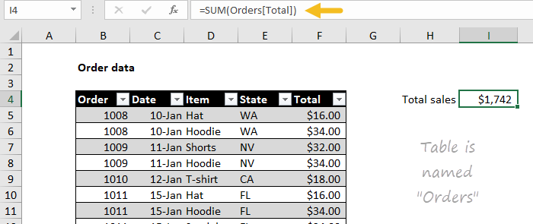

=[SUM](https://exceljet.net/excel-functions/excel-sum-function)(Orders[Amount])

### 12. Easy dynamic ranges

The single biggest benefit of tables is that they automatically expand as new data is added, creating a dynamic range. You can easily use this dynamic range in your formulas. For example, the table in the screen below is named "Properties". The following formulas will always return correct values, even as data is added to the table:

=[ROWS](https://exceljet.net/excel-functions/excel-rows-function)(Properties)

=[MAX](https://exceljet.net/excel-functions/excel-max-function)(Properties)

=[MIN](https://exceljet.net/excel-functions/excel-min-function)(Properties)

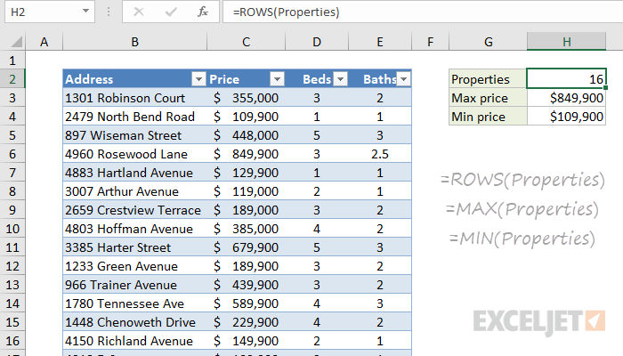

### 13. Enter structured references with the mouse

An easy way to enter structured references in formulas is to use the mouse to select part of the table. Excel will automatically enter the structured reference for you. In the screen below, the price column was selected after entering =MAX(

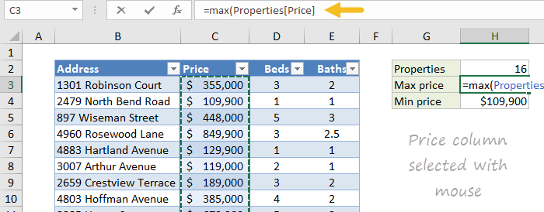

### 14. Enter structured references by typing

Another way to enter structured references is by typing. When you type the first few letters of a table in a formula, Excel will list matching table names below.

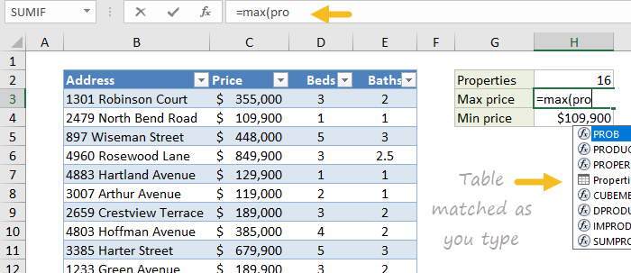

Use the arrow keys to select and the TAB key to confirm. To enter a column name, enter an opening square bracket ([) after the table name follow the same process - type a few letters, select with arrow keys, and use TAB to confirm.

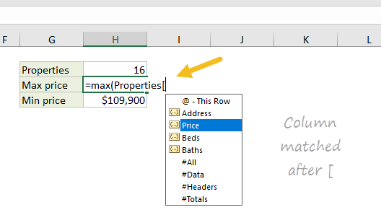

Video: [Introduction to Structured References and Tables](https://exceljet.net/lessons/introduction-to-structured-references)

### 15. Check structured references with a formula

You can quickly check a structured reference with the formula bar. For example, the following formula will select data in the "Address" column in the "Properties" table shown above:

=Properties[Address]

And this formula will select the headers of the table:

=Properties[#Headers]

Video: [How to query a table with formulas](https://exceljet.net/lessons/formulas-to-query-a-table)

Video: [How to use SUMIFS with a table](https://exceljet.net/lessons/how-to-use-sumifs-with-an-excel-table)

### 16. Change table formatting with one click

All Excel tables have a style applied by default, but you can change this at any time. Select any cell in the table and use the Table Styles menu on the Table Tools tab of the ribbon. With one click, the table will inherit the new style.

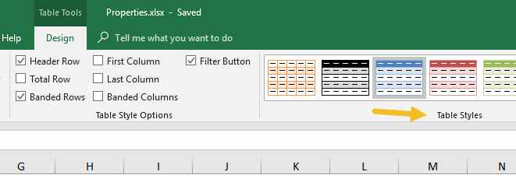

### 17. Remove all formatting

Table formatting is not a requirement of Excel tables. To use a table without formatting, select the first style in the styles menu, which is called "None".

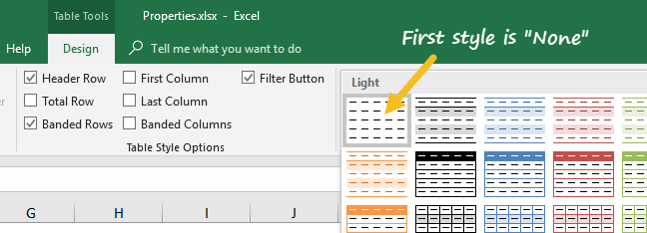

Tip: you can use this style to remove all table formatting before converting a table back to a normal range.

### 18. Override local formatting

When you apply a table style, local formatting is preserved by default. However, you can optionally override local formatting if you want. Right-click any style and choose "Apply and Clear formatting":

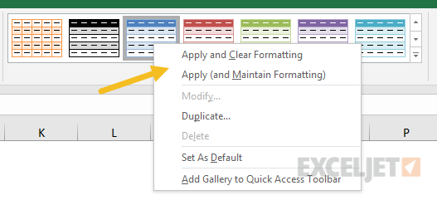

### 19. Set a default table style

You can right-click any style and choose "Set as Default". New tables in the same workbook will now use the default you set.

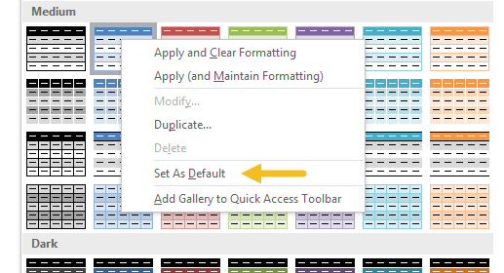

Note: to set a default table style in new workbooks, create a custom start-up template [*as described in this article*](https://exceljet.net/how-to-set-a-default-template-in-excel). In the template file, set the default table style of your choice.

### 20. Use a Table with a pivot table

When you use a table as the source for a pivot table, the pivot table will automatically stay up to date with changes in data. Watch the video below to see how this works.

Video: [Use a table for your next pivot table](https://exceljet.net/lessons/why-you-should-use-a-table-for-your-pivot-table)

### 21. Use a table to create a dynamic chart

Tables are a great way to create dynamic charts. New data in the table will automatically appear in the chart, and charts will exclude filtered rows by default.

Video: [How to build a simple dynamic chart](https://exceljet.net/lessons/how-to-build-a-simple-dynamic-chart)

### 22. Add a slicer to a table

Although all tables get filter controls by default, you can also add a slicer to a table, to make it easy to filter data with large buttons. To add a slicer to a table,  click the Insert Slicer button on the Design tab of the Table Tools menu.

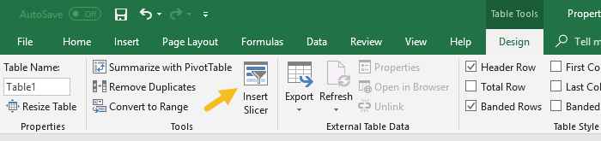

The table below has a slicer for Department:

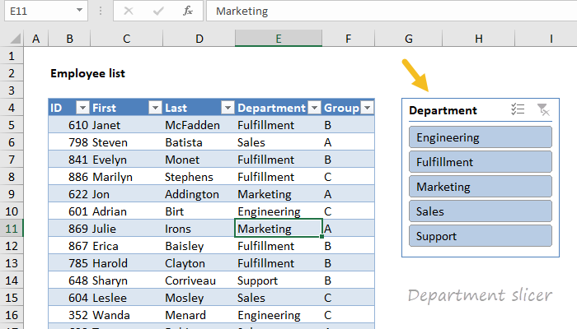

### 23. Get rid of a table

To get rid of a table, use the Convert to Range command on the Table Tools tab of the ribbon.

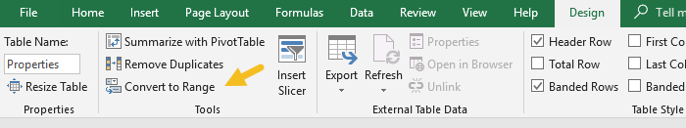

You might be surprised to see that converting a table back to a normal range doesn't remove formatting. To remove table formatting, first apply the "None" table style, then use "Convert to Range".